Task 10: Write a program on Arduino Uno to detect gas using mq5 sensor

**Aim:**

To design and implement an Arduino-based gas detection system using the MQ-5 gas sensor to detect the presence of gases in the environment.

**Apparatus Required:**

1. Arduino board (e.g., Arduino Uno)

2. MQ-5 gas sensor – 1 No

3. Jumper wires As requires

4. Breadboard – 1 No

5. Buzzer – 1 No

**Procedure:**

* Log in to your Tinkercad account and create a new circuit simulation.
* Add components to the simulation workspace: Arduino Uno board, MQ-5 gas sensor module, and buzzer module.
* Connect the components as follows:
* Connect the VCC pin of the MQ-5 sensor to the 5V pin of the Arduino.
* Connect the GND pin of the MQ-5 sensor to the GND pin of the Arduino.
* Connect the analog output pin (AO) of the MQ-5 sensor to analog pin A0 of the Arduino.
* Connect the positive (anode) pin of the buzzer to digital pin 8 of the Arduino.
* Connect the negative (cathode) pin of the buzzer to the GND pin of the Arduino.

**Code:**

**int sensor = A0;**

**int Gas = 0;**

**int limit = 47;**

**void setup() {**

**Serial.begin(9600);**

**}**

**void loop() {**

**Gas = analogRead(sensor);**

**Gas = map(Gas, 306, 750, 0, 100);**

**if (Gas > limit) {**

**tone(8, 1650);**

**}**

**delay(300);**

**noTone(8);**

**}**

**Circuit Diagram:**

**Input:**

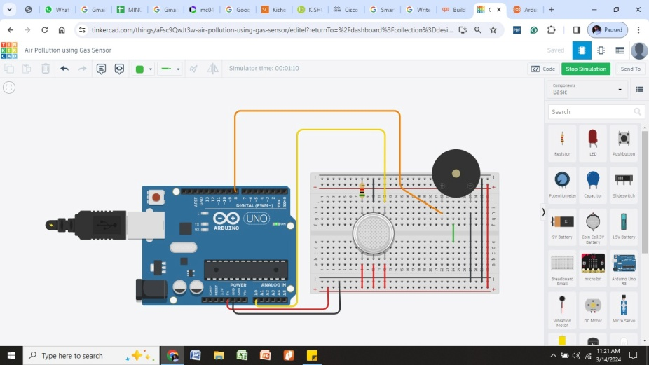

**Output:**

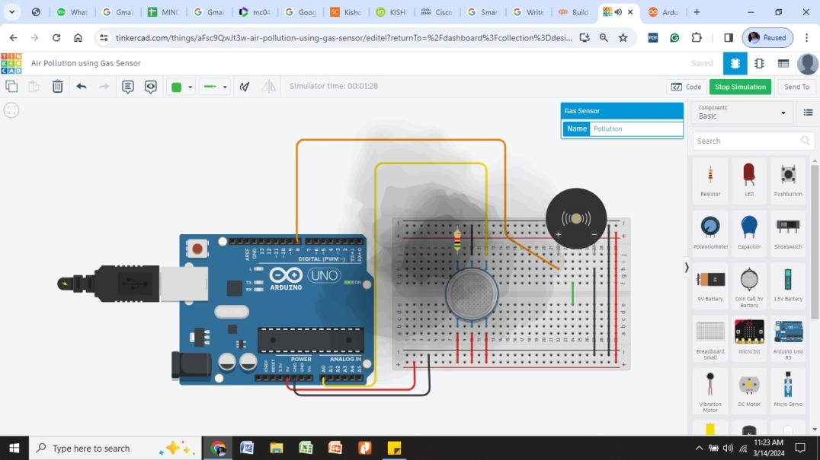

**Result:**

Thus the gas senorand implement an Arduino-based gas detection system using the MQ-5 gas sensor to detect the presence of gases in the environment successfully executed and verified.